Translation initiation start prediction in human cDNAs with high accuracy
Artemis G. Hatzigeorgiou
Bioinformatics Vol.18 no.2 2002 P343~350
Abstract
The author improved the recent Translation Initiation Start (TIS) prediction methods by applied two modules based on Artificial Neural Network (ANN).
- Motivation
The importance of finding the TIS.
The existing methods are quite flexible, but lack of accuracy.
Based on ANN, combine two methods which are also based on ANN.
- Introduction to ANN
Input → (choose goals to learn) → start learning
→ (adjust weights in processes) → (achieve stop moment) → output
- Special scanning models
- Leaky scanning
- Reinitiation scanning
- The two modules
Consensus ANN：
1.Sensitive to the conserved motif
2.Trained with cascade correlation algorithm.
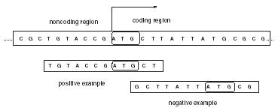
Coding ANN：
- Sensitive to the coding/non-coding potential around the start codon
- Trained with an improved version of backpropagation algorithm. The best results were obtained by applying the codon usage statistic to the sequence window.
- Integrate methods
- We use codon usage statics as the inputs of coding ANN.
- The putative coding region included in the longest ORF was calculated. If score is too low, choose another ORF.
3. For each in-frame ATG, calculate its consensus score .The score is consider as the input of consensus ANN.
4. For the same if-frame ATG, a coding difference score was calculated by building the difference between all coding scores which 60 positions before and after.
5. Putative TIS was obtained by combing the output of consensus ANN and the coding difference.
- Results
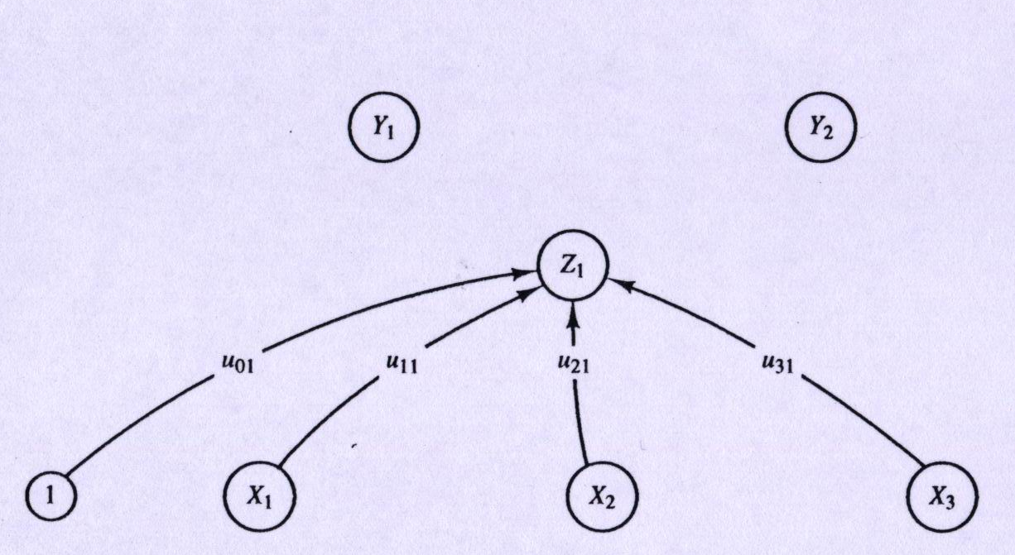
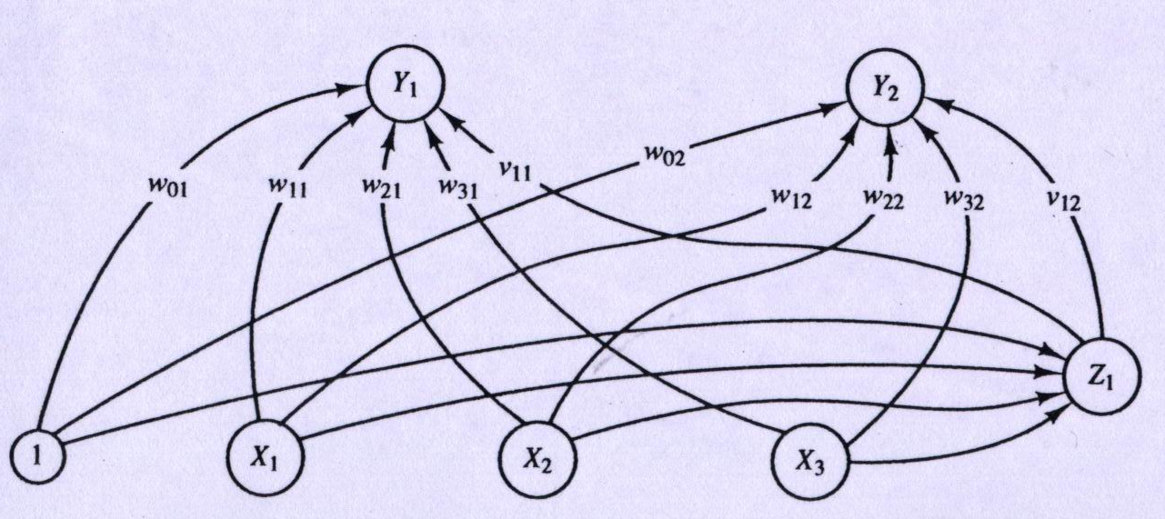
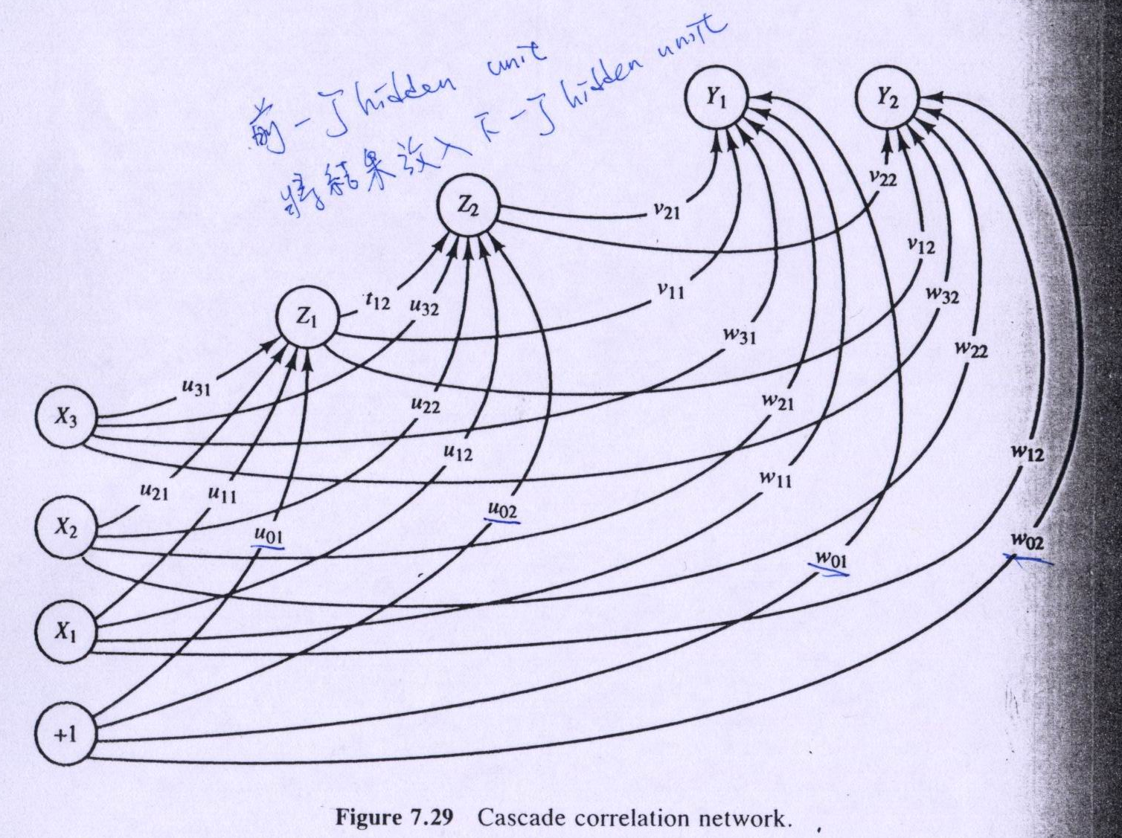
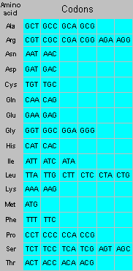
Created by: Chia-Ling Sun
Date: October 25,2002

